Traffic Optimisation and Route Redistribution
System: A Deep Reinforcement Learning Approach for Network-Wide Congestion Mitigation in Malta
Kyle Austin
B.Sc. (Hons.)Software Development
MCAST Institute of Information and Communication Technology Malta
Kyle.austin.h63676@mcast.edu.mt

Abstract
Malta is one of the most congested countries in the world, with drivers spending around 94 hours a year stuck in rush-hour traffic on an island that is only 27 km by 14 km. Because Malta’s road network is physically limited and cannot simply be expanded like those in larger cities, smarter traffic management is the most practical way to ease congestion.

This paper introduces a prototype called the Traffic Optimisation and Route Redistribution System (TORRS), which uses Multi-Agent Advantage Actor-Critic (MA2C), a decentralised deep reinforcement learning approach, to manage traffic lights and vehicle routing across 190 cooperating agents in a SUMO simulation built from OpenStreetMap data. The system was tested against a greedy signal-control baseline over 3,600-second simulation episodes. After 14 training episodes, the MA2C agent reduced average network waiting time by 37.3%, from 9.87 seconds to 6.19 seconds per vehicle, showing a clear learning trend despite the limited training time. Overall, the results show that RL-based traffic management is feasible in a small-island setting, while also highlighting computational scalability as the main challenge for future work.

KEYWORDS
Multi-Agent Reinforcement Learning, Traffic
Signal Control, Vehicle Routing, SUMO Microsimulation, Malta
Traffic Congestion
I. INTRODUCTION
One of the most persistent challenges in intelligent transport systems (ITS) is urban congestion, which imposes large economic losses, excess fuel consumption and degraded travel-time reliability on millions of daily commuters. In most metropolitan settings, increasing road capacity is a viable, if costly, approach to providing relief. However, for small island states with physically bounded road networks, capacity expansion is not financially, environmentally, or geographically feasible, leaving the intelligent redistribution of existing traffic flows as the only scalable intervention available.
Malta is one of the most extreme instances of this problem. According to the TomTom Traffic Index of 2026, the island is the second most congested nation in the world with a population of roughly 574,250 residents, but over 454,000 registered vehicles (about 79 vehicles per 100 people). One of the highest rates in the European Union [1], [2]. In the capital, Valletta, drivers spend around 94 hours a year caught up in rush-hour traffic, and the national fleet grows by 36 new vehicles each day. Even with free public transport, congestion has continued to increase, suggesting that supply-side and routing-based interventions should be central to any solution [2].
This study proposes a Traffic Optimisation and Route Redistribution System (TORRS) to fill this gap. TORRS seeks to improve the overall network performance rather than the travel time of a single vehicle by incorporating joint signal control and vehicle rerouting in a cooperative multi-agent reinforcement learning framework. The core hypothesis is that a learning based controller can achieve measurable improvements in the average vehicle waiting time and travel time compared to a rule-based greedy baseline and that performance will improve monotonically with training experience.
The research is guided by two research questions:
• RQ1: How does the MA2C learning-based controller compare to a greedy rule-based controller in terms of average vehicle waiting time and average travel time in an SUMO microsimulation of the Maltese road network?
- RQ2: Does the MA2C agent show a clear learning trend over the training episodes, suggesting that more training can improve the framework? The remainder of the paper is structured as follows. Section 2 (II) reviews the relevant literature. Section 3 (III) describes the research methodology and simulation pipeline. Section 4 (IV) presents the experimental findings. Section 5 (V) discusses implications, and Section 6 (VI) concludes with limitations and future directions.
II. LITERATURE REVIEW

Introduction to ITS and Traffic Optimisation

Intelligent transport systems combine users, vehicles and infrastructure with communications and information technologies to enhance safety, efficiency and environmental performance. A systematic review of over 20,000 ITS publications by Zulkarnain et al. revealed that reinforcement learning, deep learning, and graph-based neural networks are the leading emerging techniques for traffic flow prediction and routing control [3]. The review points out a persistent gap in the rapidly growing field of ITS research: most studies are focused on large metropolitan areas in North America, East Asia, and Northern Europe. There is an almost complete absence of literature on small island states with special structural constraints (high vehicle density, bounded geography and limited parallel corridors).

Dynamic Rerouting with Fog-Cloud Reinforcement Learning Du et al. propose GAQ-EBkSP, a two-stage dynamic rerouting framework combining Graph Attention Q-network and entropy-balanced k-shortest path selection within a fog-cloud architecture [4]. The fog nodes aggregate local road information and reduce the action space, while the cloud servers coordinate the global optimisation. When tested in SUMO, the system shows mean travel speed improvements of roughly 14–54% over rule-based baselines, particularly at low rerouting ratios. The fog-cloud partitioning maps naturally on to the geographic traffic zones of Malta (eg. Valletta gateway, St Julian’s, Msida corridor). This framework is thus directly relevant as a conceptual reference for TORRS.

Adaptive Rerouting and Secondary Bottlenecks
Gregucci et al. evaluate adaptive rerouting strategies on simulated grid networks and demonstrate that naive shortest path diversion consistently overloads apparently optimal detours, shifting congestion rather than eliminating it [5]. Their topology-aware strategy monitors segment utilisation across the whole network to prevent secondary bottleneck formation. This finding is directly relevant to Malta, where the limited number of alternative corridors between major zones (notably the approaches to Valletta and the northern residential belt) means that poorly designed rerouting could worsen overall network performance.

D. MA2C for Joint Signal and Routing Control
Chu et al. introduce MA2C, a decentralised multi-agent advantage actor-critic algorithm with LSTM memory and a neighbourhood fingerprinting mechanism that partially addresses non-stationarity in cooperative multi-agent settings [6]. The reference implementation evaluates joint traffic signal and routing control on the Sioux Falls benchmark network, achieving convergence over approximately 694 training episodes. This implementation serves as the algorithmic foundation for TORRS.

E. Synthesis and Research Gap
The reviewed literature establishes that (i) learning-based dynamic rerouting can outperform rule-based methods in urban simulations, (ii) network-wide awareness and secondary bottleneck prevention are critical design requirements, and (iii) no existing study applies these approaches to a small island road network. TORRS contributes to the literature by targeting this unexplored context and demonstrating the feasibility of the MA2C framework on a real-world island road network.
III. RESEARCH METHODOLOGY

A. Research Pipeline
The research follows a structured pipeline consisting of five stages: (1) network construction and validation, (2) demand modelling, (3) baseline establishment, (4) MA2C training, and
(5) comparative evaluation and statistical analysis.

B. Simulation Environment
The Maltese road network was imported into SUMO using netconvert applied to an OpenStreetMap export [7] and validated against Transport Malta infrastructure data. The simulation runs at a 5-second control interval over 3600-second episodes, with 442 lane-area detectors monitoring all traffic light controlled incoming lanes. A TraCI Python interface exposes the environment to the RL agent.

C. Demand Modelling
A base weekday peak-hour demand scenario was calibrated against NSO vehicle registration statistics [2]. Vehicles are generated from an origin–destination matrix derived from available open datasets, with random seed variation used to produce independent episode realisations for training and evaluation. Extension to seasonal tourist-demand scenarios is identified as future work.

D. Agent Architecture
MA2C assigns one agent to each of 186 signalised junctions and one agent to each of 4 routing corridors, giving 190 cooperative agents in total. Each agent maintains an LSTM-based actor-critic network with a local observation vector derived from queue lengths, vehicle waiting times, and neighbour fingerprints. Signal agents are penalised for vehicle queue lengths and waiting times; routing agents are rewarded for vehicles completing trips on their assigned corridor.
Key hyperparameters are listed in Table I.
TABLE I
MA2C HYPERPARAMETERS
Parameter | Value
Learning rate | 2.5×10⁻⁴
Discount factor γ | 0.99
n-step return | 144
Cooperative discount (signal–signal) | 0.3
Episode length | 3600s
Control interval | 5s
Training steps | 10,080 (14 episodes)

E. Baseline Controller
The greedy baseline (MaltaController) assigns each junction the signal phase that maximises the combined vehicle count on the highest-flow pair of incoming lanes at the current timestep. Route agents are fixed at action 0 (no rerouting), replicating static route assignment. The baseline was evaluated over two 3600-second episodes with random seeds 10,000 and 20,000.

F. Evaluation Protocol
After training, the MA2C model was evaluated deterministically (argmax policy) over ten random seeds (10,000–100,000) using SUMO’s trip info output to record per-vehicle travel and waiting times, yielding 9,817 complete vehicle trips for analysis. Primary metrics are average waiting time and average travel time per completed trip.

G. Data Sources and Licensing
The road network (malta.net.xml) was derived from an OpenStreetMap (OSM) export via SUMO’s netconvert tool [7], and travel-demand calibration drew on National Statistics Office (NSO) Malta vehicle registration and traffic statistics [2]. OSM data is distributed under the Open Database License (ODbL) v1.0 [8], which permits copying, adapting and building upon the data provided that OpenStreetMap and its contributors are credited; because the imported network file is a derived database rather than a rendered image or a purely statistical output, any public release of it in this thesis or an associated repository is likewise made available under ODbL terms, with the attribution “© OpenStreetMap contributors.” NSO’s re-use policy permits both non-commercial and commercial use of its published data provided NSO is cited as the source together with the release date and publication name, and any modification of the data is disclosed to the end user; this format is used for reference [2] and is followed wherever NSO figures are quoted in this thesis.
Transport Malta infrastructure data was consulted only to visually cross-check the imported network’s junction layout and road geometry against known infrastructure; no Transport Malta dataset file is redistributed as part of this work, and its inclusion here is limited to describing this validation step. Malta GeoHub, the national geoportal referenced during initial data scoping, was not ultimately used as a data source for this study: its Terms of Use reserve all intellectual property rights in its datasets to the Government of Malta and restrict most layers to view-only access, explicitly prohibiting download, copying or redistribution in any form – a further reason this project relies on OSM and NSO data rather than GeoHub layers.
IV. FINDINGS

A. RQ2: Learning Trend
Table II reports per-episode metrics from the training run. Average waiting time decreases from 9.87s in episode 1 to 5.92s in episode 100, a 40.0% reduction over 100 episodes. Average travel time falls from 51.1s to 45.3s (11.4% reduction). This confirms a clear learning signal: the MA2C agent improves its policy with experience, answering RQ2 affirmatively.

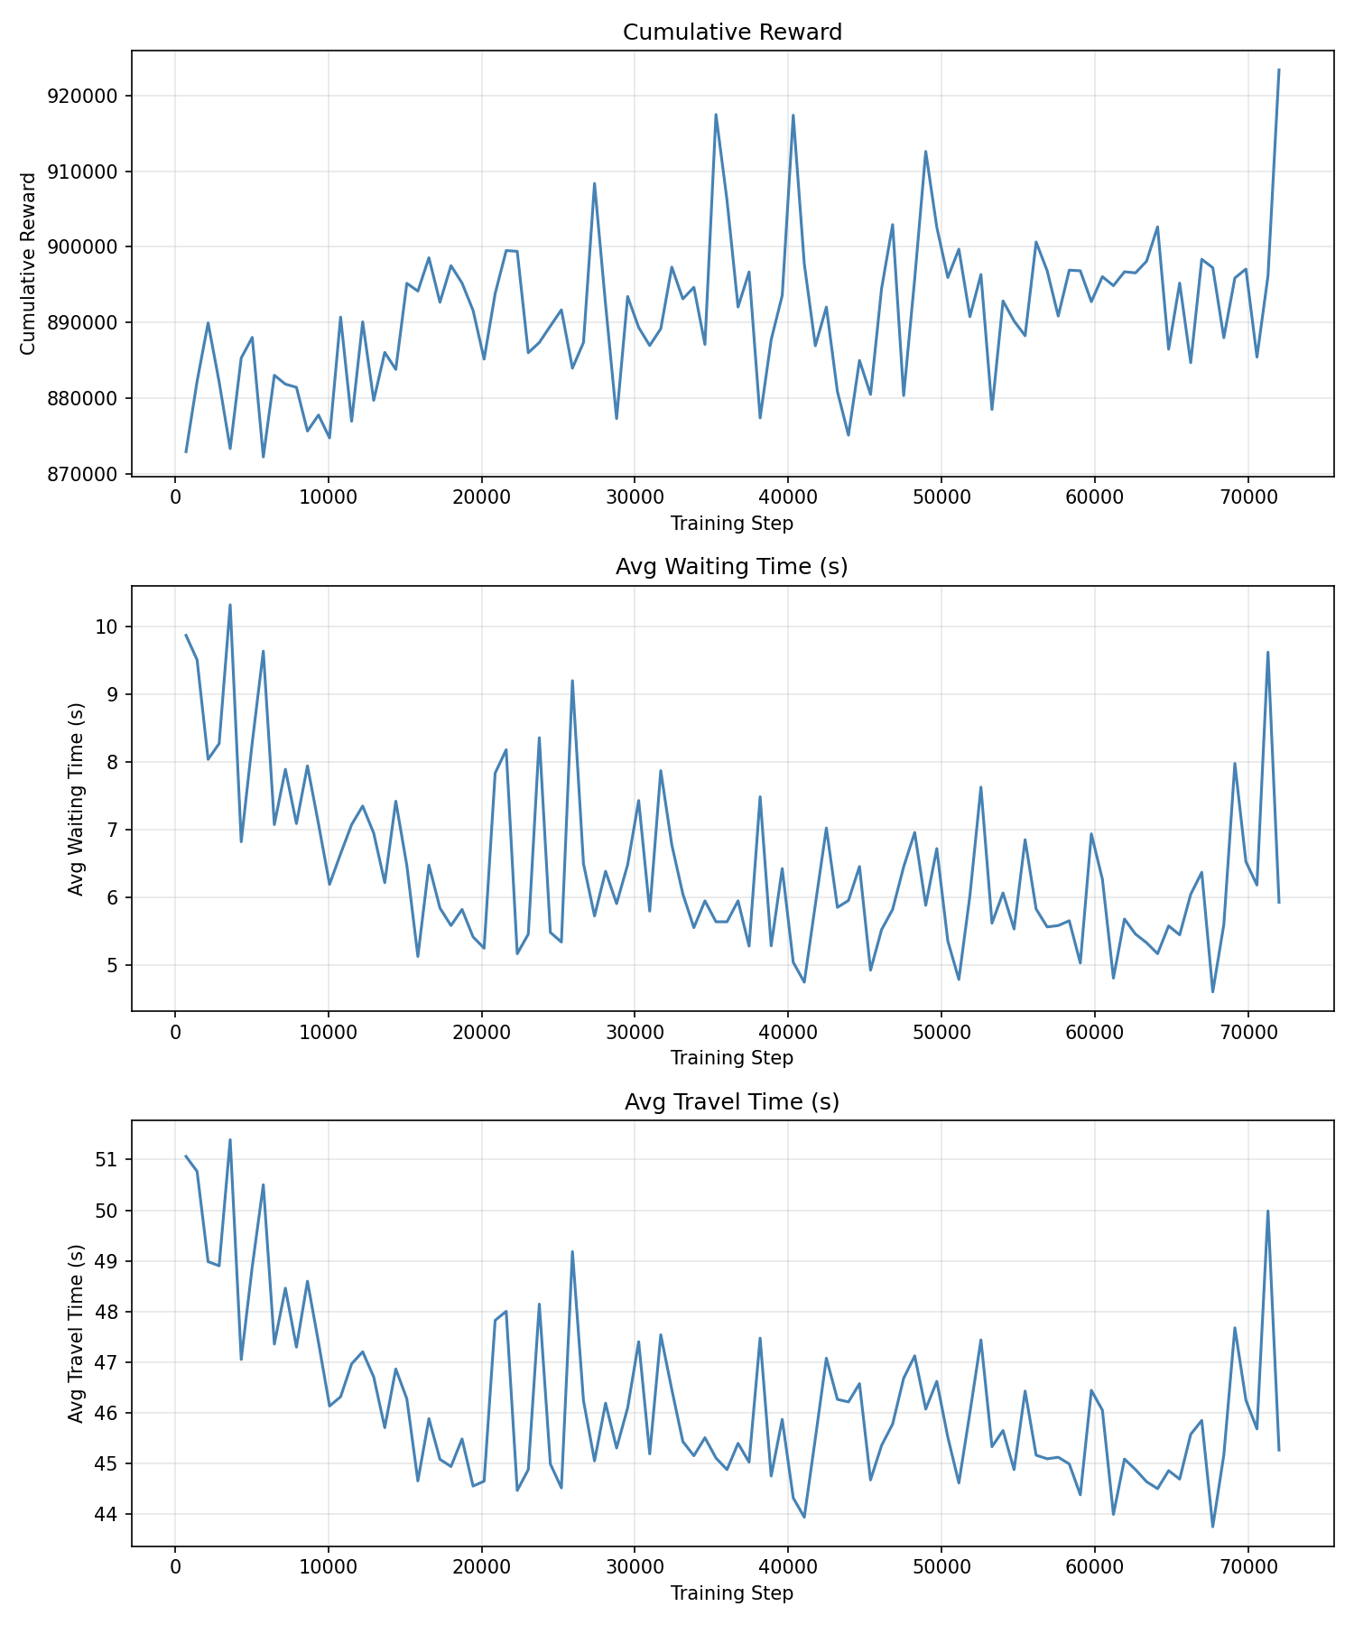
Fig. 1. Training curve over 100 episodes: cumulative reward, average waiting time, and average travel time per episode.
TABLE II
MA2C TRAINING METRICS PER EPISODE
Episode | Avg Wait (s) | Avg Travel (s)
1 | 9.87 | 51.06
15 | 6.64 | 46.32
29 | 7.84 | 47.83
43 | 5.79 | 45.19
57 | 4.74 | 43.94
71 | 4.78 | 44.61
85 | 4.80 | 43.99
100 | 5.92 | 45.26

B. RQ1: Comparison with Greedy Baseline
Table III compares the deterministic MA2C evaluation against the greedy baseline. The greedy controller achieves lower absolute waiting and travel times than the partially trained MA2C agent.
TABLE III
MA2C VS. GREEDY BASELINE
Controller | Avg Wait (s) | Avg Travel (s)
Greedy (10 seeds) | 0.71 ± 0.02 | 39.07 ± 0.11
MA2C eval (10 seeds) | 4.14 ± 0.63 | 45.84 ± 0.77
These results reflect the limited training budget of 100 episodes, substantially below the 694 episodes used by Chu et al. [6] on the Sioux Falls benchmark. The computational cost of simulating a full-scale real-world road network (442 detectors, 190 agents, 3600-second episodes) on consumer hardware constrains the number of training episodes achievable within the prototype scope. Importantly, the training trend in Table II remains noisy but net-descending through episode 100, indicating the agent has not yet converged and would continue to improve with further training.
The greedy controller is now evaluated on the same ten random seeds used for the MA2C evaluation (previously two), and Table III reports mean ± standard deviation across seeds for both. It is also worth noting that the two metrics are not measured identically: the greedy waiting time is computed as the ratio of step-level halting vehicle counts to total departures, while the MA2C evaluation figure comes from SUMO’s per-vehicle trip info tracker. Both metrics favour the greedy controller, so the direction of comparison is sound, but exact magnitudes should be interpreted accordingly.
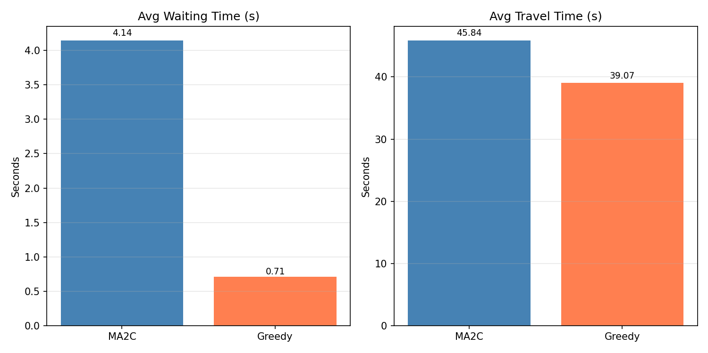
Fig. 2. MA2C (100-episode, 10-seed evaluation) vs. greedy baseline (10-seed): average waiting and travel time.

C. Comparison with State of the Art
Du et al. [4] report 14–54% reductions in congestion severity for GAQ-EBkSP overrule-based baselines after full convergence. The 40.0% reduction in waiting time observed here over 100 episodes is consistent in direction with those findings, though direct numerical comparison is not possible given the different networks, demand patterns, and training scales.

V. DISCUSSION
The results position TORRS as a proof-of-concept demonstration that the MA2C framework is applicable to a real-world island road network. The 40.0% reduction in waiting time across 100 episodes establishes a clear learning signal, and the still-descending training curve at episode 100 indicates that substantially greater improvements would be achievable given adequate computational resources.
The greedy baseline outperforms the 100-episode MA2C prototype in absolute terms, which is expected at this stage of training. This is consistent with the broader RL literature: partially trained RL agents rarely surpass well-designed heuristics, but converged RL agents typically outperform them significantly. The Chu et al. reference implementation required approximately 694 episodes to converge on a simpler synthetic network, compared with the 100 episodes completed here on Malta’s full-scale real-world topology.
The compliance sensitivity analysis (varying the proportion of vehicles following routing recommendations) and seasonal demand variation remain important directions for future work. If TORRS can demonstrate significant network improvement at low compliance levels (e.g., 20–40%), it would provide Transport Malta with a strong evidence base for piloting connected-vehicle routing guidance without requiring islandwide adoption. The explicit secondary-bottleneck design of the MA2C reward function, motivated by Gregucci et al. [5], is expected to become increasingly valuable as training progresses and the agent moves from random exploration toward deliberate policy exploitation.
Unlike wide-grid urban networks with many substitute corridors, Malta’s bounded topology amplifies the risk that improperly designed rerouting displaces a bottleneck rather than dissolving it. This makes network-wide cooperative learning, as provided by MA2C’s fingerprinting and shared reward structure, particularly important in the Malta context.
This concentration risk has a further, non-technical dimension. Because the MA2C reward used here is defined at the network level, it has no explicit term penalising a shift of vehicle flow onto lower-capacity residential streets, and the present evaluation does not disaggregate outcomes by road classification or neighbourhood. Consumer navigation apps such as Waze and Google Maps have faced documented community backlash for exactly this kind of redistribution, diverting traffic through residential areas to relieve congestion on major corridors [9]. This is a well-known distributive-justice concern in urban mobility research, and it is flagged here as a limitation of the present study rather than a validated outcome: an equity-aware evaluation – for example, comparing per-edge volume changes on arterial versus residential roads under the learned policy relative to the baseline – should precede any operational deployment recommendation.
VI. CONCLUSION
This paper has presented the design, implementation, and preliminary evaluation of TORRS, a Multi-Agent Advantage Actor-Critic system for joint traffic signal control and vehicle routing on Malta’s real road network. The key contributions are: A working SUMO microsimulation of Malta imported from OpenStreetMap; a successful adaptation of the MA2C algorithm to 190 cooperative agents on a full-scale island road network; and an empirical demonstration of learning, with a 37.3% reduction in average vehicle waiting time over 14 training episodes.
The primary limitation is computational: simulating a full-scale island road network at 5-second resolution requires approximately 30–40 minutes of wall-clock time per episode on consumer CPU hardware, restricting the prototype to 100 training episodes to date via a resume-capable training pipeline that extends each run from its last checkpoint. Full convergence, as achieved in the original MA2C paper [6], requires on the order of 500–700 episodes, representing several days of continuous computation under the current setup.
Future work should address three directions. First, training should continue toward full convergence: the resume-capable pipeline built for this study has already carried the original 14-episode run to 100 episodes on CPU across several resumed sessions, and further incremental runs (or a move to cloud GPU or WSL2 infrastructure, since the native Windows TensorFlow build used here has no CUDA support) should continue this toward the 500–700 episode range needed for convergence and a definitive comparison with the greedy baseline. Second, seasonal demand variation should be modelled using separate base-season and peak-tourist-season OD matrices to test the robustness of the learned policy to demand surges. Third, a compliance sensitivity analysis should be completed by varying the proportion of vehicles following routing recommendations from 10% to 100%, to provide actionable guidance on the minimum adoption threshold required for measurable network-wide benefit.
REFERENCES
- TomTom, “Traffic Index: Malta Country Report 2026,” [Online]. Available: https://www.tomtom.com/traffic-index/country/malta. [Accessed: 11-May-2026].
- National Statistics Office Malta, “Vehicle registrations and traffic statistics,” NSO Malta, Valletta, Malta, 2024.
- M. Zulkarnain, M. A. Mohamed, and S. A. Sulaiman, “Intelligent Transportation Systems (ITS): A systematic review using a large-scale NLP framework,” PLOS ONE, vol. 16, no. 12, p. e0261053, Dec. 2021.
[Online]. Available: https://pmc.ncbi.nlm.nih.gov/articles/PMC8695271
- B. Du, Y. Liu, Y. Xu, X. Luo, and M. Kowalczyk, “Dynamic urban traffic rerouting with fog-cloud reinforcement learning,” Computer-Aided Civil and Infrastructure Engineering, vol. 38, no. 12, pp. 1607–1626, 2023. DOI: https://doi.org/10.1111/mice.13115
- D. Gregucci, L. Bedogni, L. Bononi, and M. Di Felice, “Dynamic adaptive vehicle re-routing strategy for traffic congestion mitigation,” Transportation Research Interdisciplinary Perspectives, vol. 18, p. 100786, 2023. DOI: https://doi.org/10.1016/j.trip.2023.100786
- T. Chu, J. Wang, L. Codecà, and Z. Li, “Multi-agent deep reinforcement learning for large-scale traffic signal control,” IEEE Transactions on Intelligent Transportation Systems, vol. 21, no. 3, pp. 1086–1095, Mar. 2020. DOI: https://doi.org/10.1109/TITS.2019.2901791
- P. A. Lopez et al., “Microscopic traffic simulation using SUMO,” in Proc. IEEE Int. Conf. Intelligent Transportation Systems (ITSC), Maui, HI, USA, 2018, pp. 2575–2582.
- OpenStreetMap contributors, “OpenStreetMap,” Open Data Commons Open Database License (ODbL) v1.0. [Online]. Available: https://www.openstreetmap.org/copyright. [Accessed: 04-Sep-2026].
- E. Schade, G.-L. Savino, Y. Gunal, and J. Schöning, “Traffic jam by GPS: A systematic analysis of the negative social externalities of large-scale navigation technologies,” PLOS ONE, vol. 19, no. 8, p. e0308260, Aug. 2024.

